## ECO 5375 – 701 T. Fomby

Economic and Business Forecasting Fall 2021

# EXERCISE 2

**Purpose**: To get some practice accessing data from the “Simply Analytics” website that I demonstrated in class. This exercise is due **Tuesday, September 7 by 6:30 PM on Canvas**.

Go to the SMU webpage and type in “Simply Analytics” and access the software. We are going to get the following cross-sectional data for the 2020 ***Texas*** Census. You are to download the following variables into a spreadsheet you can produce in Simply Analytics:

* Median Household Income 2020 (from the Income module)
* % Educational Attainment | Bachelor’s degree or higher, 2020 (from the Education module)
* % Employment Status | In civilian labor force, **unemployed**, 2020 (from the Jobs & Employment module)
* # Total for all sectors | Total Number of Establishments, 2018 (from Business Counts module)
* # Total Population, 2020 (from Population Module)

In your **Texas** spreadsheet I would label the above variables as: income, edu, unemp, estab, and pop, respectively, in first line of your spreadsheet.

After you have put together your spreadsheet, I want you to import it into the EVIEWS software package on Apps.SMU and run the following regressions and report the regression results that EVIEWS produces for each of the below two parts:

(a) ${income}_{i}= β_{0}+ β_{1}{edu}_{i}+ϵ_{i}$

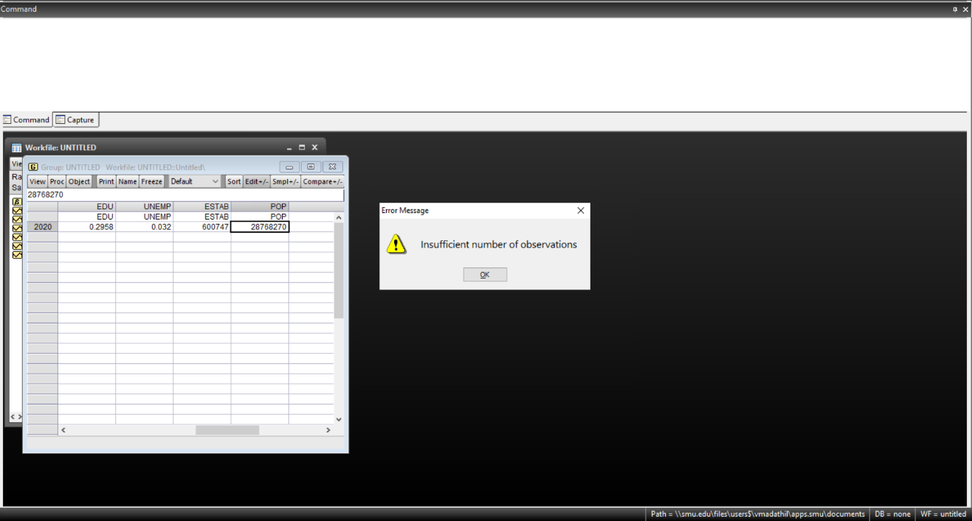

For this regression, there are an insufficient number of observations to calculate the intercept and coefficients.

(b) ${income}_{i}= β_{0}+ β_{1}{edu}_{i}+{β_{2}{unemp}_{i}+β_{3}{estab_per_pop}_{i}+ϵ}_{i}$

where ${estab_per_pop}_{i}={estab}_{i}/{pop}_{i}$.

Similarly, there is not an adequate number of observations for this regression to be calculated. 

(c) Interpret the results that you have reported in parts (a) and (b) above.

If part (a) could have been successfully completed, $β_{0}$ would be the y intercept, $β_{1}$ would be the effect of education – how much median household income would change if one unit of education is added.

Similarly for part (b), $β_{0}$ would be the y intercept, $β_{1}$ would be the effect of education, $β_{2}$ would be the effect of unemployment, and $β_{3}$ would be the effect of establishments per capita (estab/pop) on median household income.

For both parts, $ϵ_{i}$ would be the error term for the respective regressions.